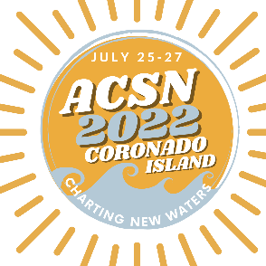

March 1, 2022
Dear [Manager’s First Name],
I’m writing to express my interest in attending the annual Alumni Career Services Network (ACSN) conference, taking place in San Diego from July 25-27, 2022, and I hope you’ll approve this request.
Today’s professional landscape features altered workplaces, and it’s imperative we share strategies for empowering alumni as they navigate an ever-changing market. #ACSN 2022: Charting New Waters aims at addressing industry changes, finding harbor in mindful solutions, and embarking on a new chapter for Alumni Career Services. The schedule of events promises to offer a unique conference experience, providing an opportunity to explore our industry’s latest products, learn from field experts, and network with colleagues, old and new.
Included in my conference registration is the following:
- A three-day immersive learning experience with hands-on programming
- Four special presentations including keynotes and panels
- Multiple workshop-style sessions to encourage open dialogue
- Four (4) meals, to include a combination of breakfast, lunch, and/or dinner along with two (2) receptions
- An exclusive networking reception with an opportunity to extend invitations to [University Name] alumni
As a member of ACSN, the early-bird registration of $575 is open now through June 10th. The cost will increase to $675 on June 11. As you know, my membership also includes access to webinars, book clubs, and other educational programming from ACSN throughout the year. Additional costs associated with the conference event include:
- Airfare: [Estimated total cost for airfare]
- Hotel: $269/night ++. Total cost for ___ nights is _____[Estimated total cost for hotel]
- Transportation: [Estimated total cost for transportation to and from the airport] Round trip range between $50 and $150. ACSN will help us coordinate shared shuttles. The hotel is offering a reduced nightly parking rate of $15 if I decided to rent a car.
- Meal Per Diem: [Estimated total cost for meal per diem. Remember that conference registration includes four meals. - $74 per day current per diem rate.]
The conference supports my professional development goals of [professional development goal #1, professional development goal #2, and professional development goal #3]. By joining industry colleagues, I’ll gain a better understanding of the trends and challenges facing our field and develop strategies for being a steward of inspiration for our alumni.

ACSN is the largest network of alumni career services professionals in the country. By being a part of this group of professionals, I will increase awareness of our field and facilitate interaction amongst colleagues across institutions. You can learn more about the conference and browse a schedule by visiting www.myacsn.org/conference.
Thank you for considering this opportunity!
[Your Name]

